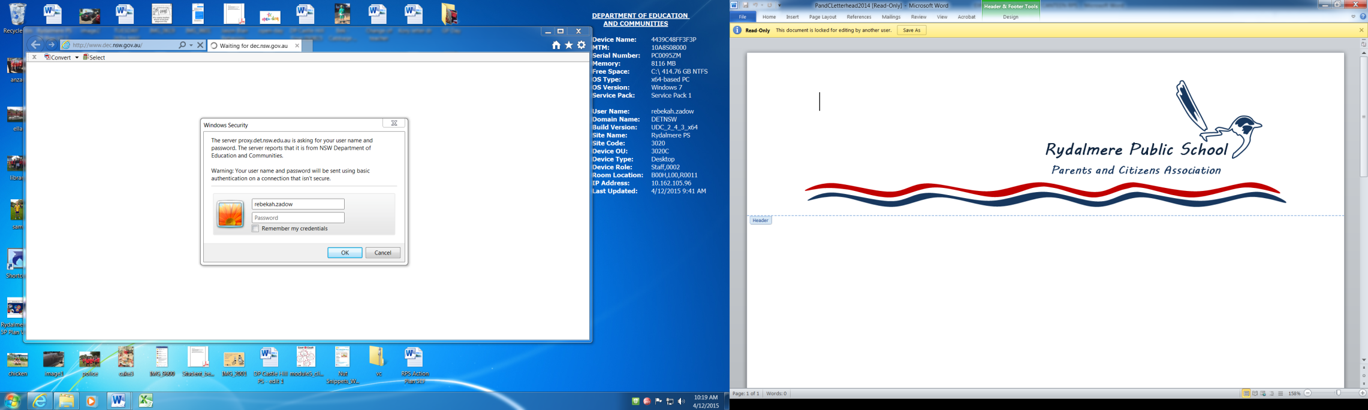**EXPRESSION OF INTEREST**

**RYDALMERE PUBLIC SCHOOL**

**CANTEEN OPERATOR – VOLUNTEER**

**DUE: 3PM FRIDAY 11TH DECEMBER 2015**

**APPLICATIONS TO BE SUBMITTED TO:** [**rydalmerepandc@hotmail.com**](mailto:rydalmerepandc@hotmail.com)

Rydalmere Public School P&C, in conjunction with the school are seeking expressions of interest for the position of canteen operator. Ideally we would like to have a canteen operating every week day, so considerations will be made as to whether the Canteen Operator can be a shared role to enable this. This commitment requires you to work 8:45-2pm on your chosen day/s.

We require an enthusiastic person/s with good management skills. Our school caters for 110 students, 20 preschool children and 12 staff.

Interested persons are invited to submit an expression of interest addressing the following:

* Demonstrated ability to lead, plan, organise and control the day to day operation of the canteen on their designated day/s
* To work with the P&C Treasurer who is responsible for the financial management of the canteen (including stock ordering) and the banking
* Ability to implement the NSW Healthy Canteen Strategies
* Ability to plan a variety of menus – summer and winter (provide examples)
* Ability to advertise menu items prominently and professionally
* Ability to motivate and communicate with and relate well to primary school aged students, volunteers and staff
* Mobile phone for use while in canteen that both the P&C and school can use to contact
* Working With Children Check clearance provided
* The exact days (Mon-Fri) that you are willing to operate the canteen

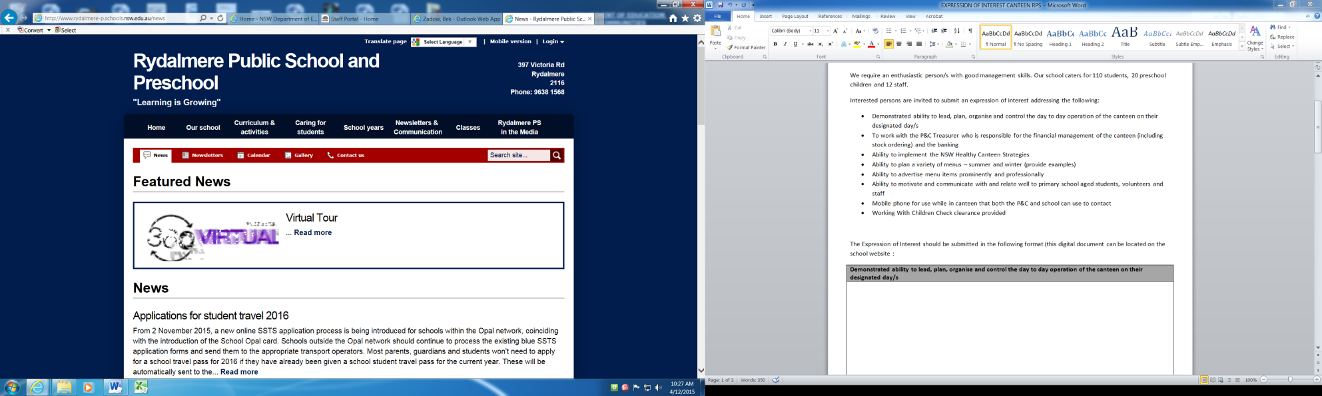The Expression of Interest should be submitted in the following format (this digital document can be located on the school website under the ‘News’ tab : )

|  |
| --- |
| **Demonstrated ability to lead, plan, organise and control the day to day operation of the canteen on their designated day/s** |
|  |
| **To work with the P&C Treasurer who is responsible for the financial management of the canteen (including stock ordering) and the banking** |
|  |
| **Ability to implement the NSW Healthy Canteen Strategies** |
|  |
| **Ability to plan a variety of menus – summer and winter (provide examples)** |
|  |
| **Ability to advertise menu items prominently and professionally** |
|  |
| **Ability to motivate and communicate with and relate well to primary school aged students, volunteers and staff** |
|  |
| **Mobile phone for use while in canteen that both the P&C and school can use to contact** |
|  |
| **Working With Children Check clearance provided (please attach documentation)** |
|  |
| **The exact days (Mon-Fri) that you are willing to operate the canteen** |
| * Monday * Tuesday * Wednesday * Thursday * Friday |